Griffin Rzonca and David Mengel

ECE 445, Team 13

Project: Tesla Coil Guitar Amp

**High Level Requirements:**

There are three primary requirements that this design must fulfill in order to be considered successful:

1. The tesla coil can produce visible sparks
2. The coil can produce several different notes and tones
3. The coil will take input from the guitar to determine the notes played

**Block Diagram:**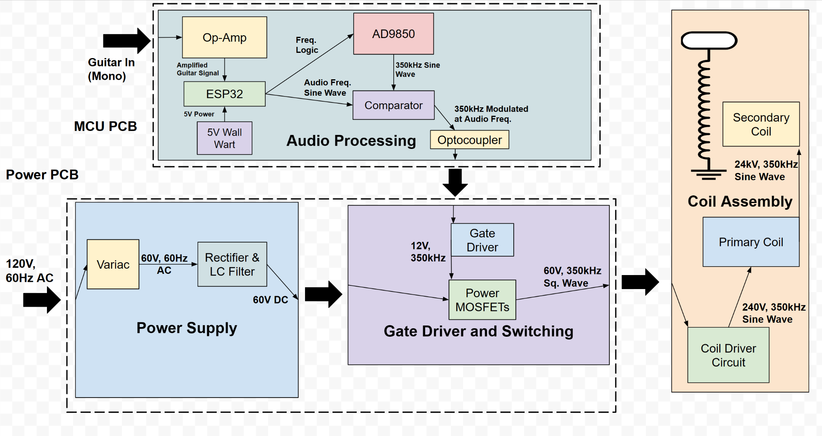

**Subsystem Requirements:**

**Audio Subsystem:**

| **Requirement:** | **Verification:** |
| --- | --- |
| Output pulse wave must be at resonant frequency in range 100k-400kHz with 500Hz granularity | Measure waveform frequencies with an oscilloscope |
| Subsystem must output a signal of 5 ± 1V to the gate driver and switching subsystem | Use voltage probe to measure output |
| Subsystem can create a pulse wave that is either pulses of the resonant frequency or a PWM wave where the resonant frequency is modulated with the audio frequency | Duty cycle can be measured using an oscilloscope to determine the ratio of the time the circuit is on vs off |

**Power Subsystem:**

| **Requirement:** | **Verification:** |
| --- | --- |
| After filtering, limit ripple voltage to 10% | Measure waveform with oscilloscope and observe the min to max voltage variation |
| Voltage sent to switching must be able to reach at least 60V, and any value lower | Monitor using oscilloscope or DVM |
| Circuit must be able to limit DC input current to to 10 ± 5A | Monitor using oscilloscope |
| Subsystem must not trigger wall outlet circuit breaker: max wall outlet power is 1.5kW[2], so limit power consumption to below 1.5kW | Monitor outlet to ensure breaker is not triggered |
| Capacitors must be discharged to below 10 volts 5 minutes after coil power is disconnected | Install bleeder resistors on capacitors and use voltage probe to test capacitor voltage |

**Gate Driver and Switching Subsystem:**

| **Criteria:** | **Verification:** |
| --- | --- |
| Limit Current Spikes through subsystem to 30A | Use oscilloscope to ensure operating current does not exceed the set limit |
| Subsystem must be able to be prevented from reaching over 100 V on any power rails | Monitor voltage and use Variac to step down voltage if necessary |
| Limit power consumed to 1kW | Measure current and voltage on DC Bus with current and voltage probes |
| Limit subsystem temperature to T ≤ 100℃ | Use thermal camera to measure MOSFET temperatures after one minute of continuous operation |

**Coil Assembly Subsystem:**

| **Requirement:** | **Verification:** |
| --- | --- |
| Prevent capacitors from being destroyed during operation | Visual inspection to ensure no capacitors break during coil operation |
| Create sparks that are >2 cm in length | Measure if sparks reach grounding rod or if they break off in the wrong directions |
| Circuit is protected - all sparks are directed to grounding rod, no arcing to surroundings or the rest of the system | Visual inspection during coil operation |